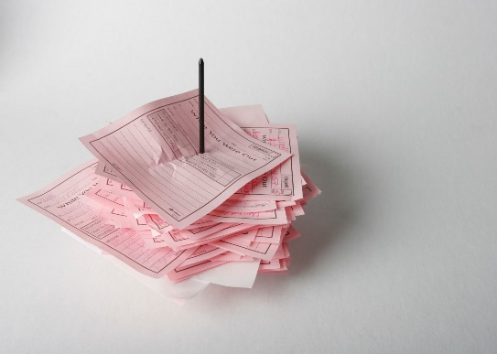
You Can’t Bore People into Buying from You
by Chris Lytle
In 1976 there were no cell phones or email. We had a message nail.
When you walked into the office, the first thing you did was retrieve all the little pink message slips from the message nail and go through them to see which calls needed to be returned. One afternoon there was a message for me from the new manager at one of my car dealer clients. The fact that the message was on a pink slip was ironic because the new guy was firing me.
The message read, "Bob Voss, Schappe-Conway Dodge, called. Cancel all our advertising schedules immediately. You will have a twenty-minute meeting to re-pitch the entire year's advertising budget on Thursday. Your appointment with Mr. Voss is at 1:20 P.M."
Twenty minutes to present an entire year's advertising program. The meeting was in forty-eight hours.
The bad news: The client had canceled his advertising. The worse news: I was his 1:20 meeting. That meant he was meeting with sales reps from every media for twenty minutes each. He had an 8:00, 8:20, 8:40, 9:00, 9:20, 9:40, and so on. I was going to be the fourteenth media rep he would see that day.
Mr. Voss canceled his advertising on Tuesday. The twenty-minute meeting was set for Thursday. In preparing for the meeting, I called a salesperson at the dealership. I learned from her that Mr. Voss had just been hired away from Dodge City in Milwaukee to turn around the Dodge dealership in Madison. For those of you who can remember back that far, that was pre-Lee Iacocca, and Dodge was struggling nationwide.
I planned my approach.
I decided I didn't want to be like every other rep, in there for twenty minutes desperately presenting the year's budget. My goal was to sell Mr. Voss on the fact that twenty minutes wasn't long enough to plan a year's worth of advertising. My strategy was to differentiate myself and my presentation from that parade of media reps I imagined he was meeting with and the presentations they were making.
I made a conscious decision to not even present him a year's schedule, even though that was what he requested. I left the Arbitron local ratings book at the station. I didn't pack a rate sheet or a brochure on the station. All I had in my Fiberglas™ briefcase when I walked in the door was my customer needs analysis form and a notepad.
At precisely 1:20 P.M. on Thursday, the door of Mr. Voss's office opened and out came the salesperson with the one o'clock meeting. He was rolling his eyes and surreptitiously shaking his head in disgust. As he made his exit, I made my entrance. As I walked into Mr. Voss's office with my briefcase in my left hand, I extended my right hand and said, "Good afternoon, Mr. Voss, I'm Chris L- . . ."
"You're my 1:20 appointment. Sit down and pitch me." He said it in an obnoxious, but not abusive way.
"This is going to be an interesting meeting," I thought to myself. I had never been to a seminar on neuro-linguistics to learn about mirroring a client, but I was astute enough to realize that here was a tough customer and I had better change my style of selling and become the salesperson he wanted me to be. Gruff, quick, and to the point. Get to the bottom line.
"Mr. Voss, I don't know if you should be on our station or not," I said. I knew he hadn't heard that line from any one of the thirteen eager salespeople who had come before me.
"What do you mean you don't know if I should be on your station or not?" he shot back.
"Well, Mr. Voss, I know that you're already a successful car dealer, and I've heard about your work with Dodge City. We're having the biggest month in the history of our radio station. So, we're both successful and we're doing it without each other."
(Even when I was twenty-six years old, I wanted to see myself as providing a valuable service instead of taking someone's money.)
I looked him in the eye and said, "I work with Len Mattioli at American TV, Jon Lancaster at his dealership, and the Copps account. I'm helping them get some big sales increases.
"This is the way I work with them. See if it makes sense to you.
"Most of my important clients want ideas that help them improve traffic, sales, and profits. To be able to bring ideas instead of just rates and ratings, I use a tool that helps me learn about nine key areas of your business that may give you an advertisable difference over your competitors. It takes anywhere from an hour to an hour and one half to do this right.
"I could present a schedule and show you what your predecessor and I were working on. But I imagine you have bigger goals and tougher targets than Steve did, or you wouldn't be in that chair.
"Mr. Voss, I want to be in a position to make an intelligent proposal based on your objectives and not just my need to sell you a schedule. Does that make sense?"
"Yes," he said, his voice softening a little bit.
And then I made The Gesture. I raised my hand and gestured to his credenza and he looked around. On the credenza was a pile off all the media kits every other salesperson had brought to the meeting. "Mr. Voss," I said, still gesturing at the stack, "have you had any intelligent proposals so far today?"
The man changed before my very eyes. The gruff, powerful executive was now slumping in his chair. His face sagged. He looked at me and said these words: "Chris, this has been the most boring day of my life."
"Mr. Voss? Can we go through this analysis together?"
"Chris, please, call me Bob."
"Bob, what are your plans for turning this dealership around?"
Ninety minutes later, Bob Voss accompanied me out of his office. There were four salespeople in the waiting room, like planes circling over O'Hare Airport on a stormy night.
Two weeks later, the client was back on our station in a big way. They were one of the top ten advertisers on the station that year.
The most boring day of Bob Voss's life was made up of thirteen consecutive meetings with people presenting their rates, ratings and schedules. They were talking about buying advertising. Nobody talked to him about selling cars, which was the only thing he was really excited about.
I might have made a quicker sale if I had pitched him in the allotted twenty minutes, but I don't think I would have made a bigger or longer-lasting sale. I would have been just one of the vendors he bought from, not one of the people he looked to for advertising advice and ideas.
And it doesn't matter what you're selling.
Accidental Salesperson Axiom: You can't bore people into buying.
Corollary: Your clients buy the way you sell before they buy what you sell.
(This is an excerpt from The Accidental Salesperson: How to Take Control of Your Career and Earn the Respect and Income You Deserve. Permission granted to reprint and share with attribution to the author.)

