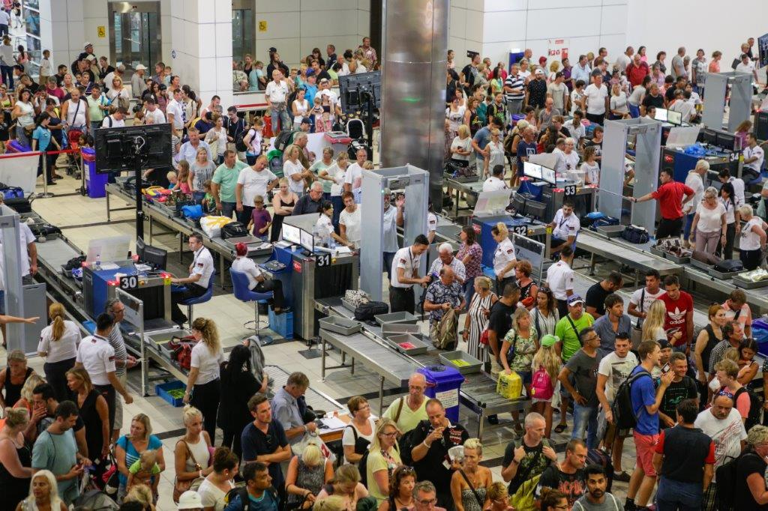
Watching a Pro Take Charge
Sales pros aren't the only ones who can offer valuable lessons in the art of persuasion. I saw a great sales job in the Tampa airport by a person who probably didn't even see himself in sales. It was an airport security person who did a masterful job of crowd control.
We had an 8 a.m. flight from Tampa to Toronto. That meant a 5:45 a.m. taxi to an already crowded Tampa airport. We checked our luggage at the ticket counter, boarded the shuttle and rode to the terminal where we had to clear security.
As we got off the train, we could see four long lines at the X-ray machines and metal detectors. And there was another line snaking back to the end of the terminal.
"Please stop here and form a new line," said the security guy in a commanding voice. "I'll be with you in a moment." With that, he left and started putting people from the long line into the four lines heading to the X-ray machines.
"May I have everyone's attention," he shouted. Silence. There were hundreds of people in lines and not a word from any of them. "My lines are now operating at 35 seconds per person," he told everyone. "If you set off the metal detector, we have to take you out of line and use the wand. That will slow the line down to one minute and 15 seconds per person. So take everything out of your pockets. Get your laptop computers out of their cases. You can help me keep this line moving.
"Does anyone have a 7:15 flight?" he yelled. Twenty hands shot up in the air. "I'm watching you. If you're not to the front of the line in 10 minutes, I'll walk you to the front of the line, so you can make your flight.
"Does anyone have a 7 o'clock flight?" Five hands went up. "Come with me." He checked the tickets and got them through the line. He made eye contact. He was assertive and respectful. He was in complete control.
And as I stood in line, I watched him and marveled how someone could take a job and transform it into an act.
Life is one big seminar. The security guard was getting people to do what he needed them to do. Here's what I learned from the security guy that you can apply directly to your sales career:
Empathy Is Important
The security guy knows people are skittish about flying. The long lines and added security have made flying even more stressful.

Communication Is Critical
When he told us what our responsibilities were and quantified the amount of time we could save by not setting off the metal detector, the security guard made us part of the solution. People who know why they are being asked to do something are much more likely to do it. Great leaders use the word "because" a lot.
Systems Are Vital
He created a system that worked. Everyone who came into that terminal saw him work the room. Travelers in the line knew they were in a system that worked, and they knew they had a part to play in the operation. The person with the plan is someone we all respect.
Taking Your Job Seriously Wins Others Over
He was enjoying what he was doing. He may have done it 4,000 times, but his new audience (arriving every seven minutes on the shuttle) hadn't seen his act. He genuinely enjoyed being in charge of the situation, and it showed in his smile, his voice and the way he moved about the room.
I saw something pretty amazing that Sunday morning at the Tampa airport. I saw a person who had decided to take the job of airport security to the next level. In doing so, he taught me some things about crowd control and reminded me what it means to be a professional.
Apply these lesson to your sales job? Think about it, at least.
(Permission granted to reprint this article with attribution to the author, Chris Lytle.)

