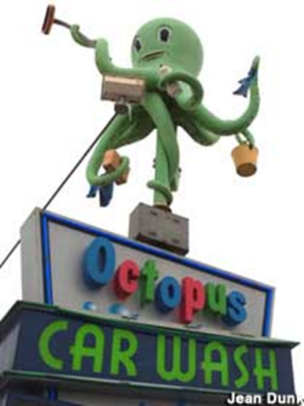
The Science of Persuasion
Influence, The Science of Persuasion is the book by Robert J. Cialdini and Steve Martin. You can watch the eleven-minute white board summary of the book on YouTube. One of the authors “secrets” of persuasion is that people tend to say “yes” to people they like.
They pose the question: What causes one person to like another. They list three important factors of liking:
- We like people who are similar to us.
- We like people who pay us compliments.
- And we like people who cooperate with us toward mutual goals.
When I was a young radio advertising salesperson, I started reading the trade magazines of my top ten or 15 clients. That helped learn their jargon and speak the language they use in their businesses.
Retailers talk about inventory “turns.” Car dealers talk about “ups,” “lay downs” and “floor planning.”
I was reading a copy of Auto Laundry News while preparing for a meeting with my guy at Octopus Car Wash and came across the term “cheater wax.” That’s the wax that a car wash mixes with the rinse water even if you don’t buy the hot wax they offer on the menu. “Cheater wax” makes the water bead up. That means the blower works more efficiently and it saves the car wash money on power.
When I asked Jeff, the manager at Octopus whether he used cheater wax, he escorted me into his office and closed the door. “Never mention that in front of people in the lobby,” he said. “This is an industry secret. Look Chris, we make a lot of our profit on the hot wax. It costs a nickel and we sell it for four dollars.
“What percentage of your customers purchase the hot wax?” I asked.
“About 30%.”
“What if we could get the percentage to 50% or higher?”
“It would really increase our profits,” said Jeff.
“Maybe we should be running a promotion on that,” I suggested
“Absolutely, we should.” And we did.
I liked Jeff enough to learn about his business and speak his language. By being interested in the car wash business and using the jargon of that industry during my meetings, I was able to get him to like me and say “yes” more of my ideas. Be more likeable and you’ll be more persuasive, too.
(Permission granted to reprint this article with attribution to the author, Chris Lytle.)

