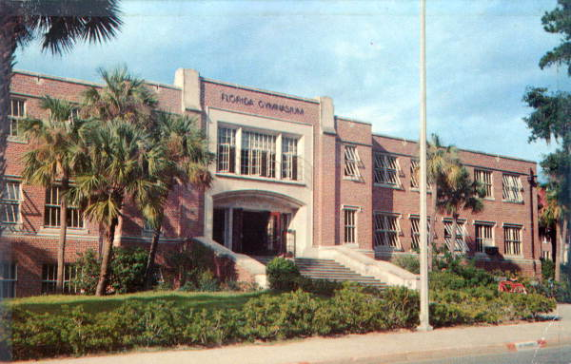
Snail Mail (Still) Sells
It’s a cold, blustery day in March 1968. When I get home from Newark (Ohio) High School, there is a postcard in the mail. It has a picture of the University of Florida on the front. The buildings are nice. But what I really notice are the palm trees.
I turn the card over and read this:
Dear Chris,
The Baldwin-Wallace College track and field team is training for the outdoor season here for the next ten days. We’ll be competing in the Florida Relays at the end of the week. I hope you’ll be down here with us next spring. How’s the weather in Newark?
Coach “Sparky” Adams
I told that story on November 9, 2015 as I was being inducted into the Baldwin Wallace athletic hall of fame. I returned to my alma mater forty-three years after graduating and had a wonderful time.
You see, I finished 2nd in the Ohio State Meet later in May and matriculated at Baldwin Wallace in September of 1968. I set the school high jump record, which held up for three years until Coach Adams recruited an even better high jumper. I won four consecutive indoor conference championships and two outdoor championships. In 1971, I finished fifth in the NCAA College Division Championships earning all-America honors. I like joke that I held the women’s world high jump record until 1984. That’s when Bulgarian Stefka Kostadinova jumped 6’10”—Here’s the link to the video of that.
I don’t know how many of those post cards Sparky sent out. But I do know we had a great track team. Coach Adams hand the knack for recruiting great sprinters, long-distance runners, shot putters and long jumpers, too.
So, I’m guessing you haven’t heard of Baldwin Wallace University in Berea, Ohio. I hadn’t heard much about it either. And I wasn’t strongly considering going there until I got a postcard with that picture of the University of Florida and a note from the head track coach on a cold, blustery day in March 1968.
I vividly remember it. And I remember deciding that very moment where I was going to college. It was the postcard, not the campus visit or the course catalogue that sealed the deal. I hope this inspires you to put pen to paper and send a note to your mentor, your parents, a client, a prospect or a long-lost friend.
Never underestimate the power of a personal note. Or a postcard. Your next note may not close the deal. But it’s going to let someone know you’re thinking about him or her. And it will get him or her thinking about you in a positive way, a way in which an email won’t.
Because sending a note takes more work, time and thought. And because you have to have a stamp.

