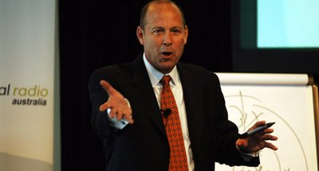
Short-Attention-Span Training
Here I am teaching the Bull's-eye Theory of Advertising in Sydney, Australia at Commercial Radio Australia’s National Sales Conference. I told them everything I knew in a 45-minute keynote.
It was my great privilege to speak at the Dayton C. Miller Honor Society induction Baldwin Wallace University. Only the top 4% of academic achievers get in.
Professor Amy Lebo wrote to request that I do the keynote. "We would like you to share your story with the inductees and their families. You'll have eight minutes."
So, I drove six hours to Berea, Ohio, hung out at my alma mater and spoke for 8 minutes. That's the shortest speech I have ever delivered.
In the picture above, I am speaking to a Radio conference in Sydney, Australia. They wanted 45 minutes. The total flying time was 18 hours, 59 minutes one way.
Today the trend is toward shorter and shorter training sessions.
Back in the day, I used to do full day seminars. Today, I create a weekly Instant Sales Training session that is 2-1/2 to 5 minutes long. You can get a free sample elsewhere on this website.
Back in the day, someone would come up to me and say, "If I can get one good idea, this will be a good seminar." Today, I share one good idea every week and everyone can listen to it on their phones on the way to see a customer.
Short attention span sales training is a lot easier on the trainer.
And the trainee.
Now sales learning can be a process rather than an event.
It took some time, but I've got my head around the need for short attention span sales training. Have you?
(Permission granted to reprint this article with attribution to the author, Chris Lytle.)

