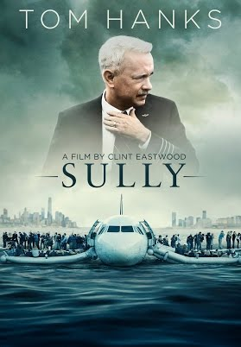
Miracle? On the Hudson
Tom Hanks stars as Captain Chesley B. “Sully” Sullenberger in Sully. The description of the movie reads thusly, On January 15, 2009, the world witnessed the "Miracle on the Hudson" when Captain "Sully" Sullenberger glided his disabled plane onto the frigid waters of the Hudson River, saving the lives of all 155 aboard. However, even as Sully was being heralded by the public and the media for his unprecedented feat of aviation skill, an investigation was unfolding that threatened to destroy his reputation and his career.

While it’s been called the “Miracle on the Hudson,” there is another way to look at it: Merriam-Webster’s online dictionary defines a "miracle" is "an extraordinary event manifesting divine intervention in human affairs." It was certainly not a miracle that a flock of geese flew into the Airbus’s engine. Apparently, that happens frequently. After that, everything that should have happened happened; The plane lost power and the captain's training took over.

Captain Chesley B. "Sully" Sullenberger guided the plane to a textbook "water landing." Sullenberger has his own air safety consultancy and an article on TheStreet.com reveals. "He had been studying the psychology of keeping airline crews functioning even in the face of crisis,” said Robert Bea, a civil engineer who co-founded UC Berkeley's Center for Catastrophic Risk Management. There is no doubt that Sullenberger is a hero. But without all his training, he might well have been a casualty. Commercial airline pilots must constantly update their skills and continue to train until they retire.

And this story is not just about the pilot and crew. Here’s how New York Mayor Michael Bloomberg put it at an evening news conference, "The FDNY, NYPD and Port Authority police all worked together. They plan for these kinds of emergencies and you saw it in action.”

Of course, a sales trainer like me is going to try to turn a near tragedy into a life lesson and a case for doing more training. Looking at an airplane floating in the water is a highly emotional image. But if you watched the coverage unfolding, what you really saw were hundreds of highly trained humans doing the jobs they trained to do. U.S. Air and New York City insist upon continual training and improvement.

At the time Sully landed the plane in the river, the airline industry had buffeted by rising fuel prices and the country’s economic malaise. While many companies cut training budgets at the first sign of a downturn, fortunately for the 155 people on board there were well-trained professionals there to rescue them. Divine intervention or training?

Do you think your salespeople will miraculously improve on their own? Or do you need to keep training and coaching them to keep them sharp? Call me if you want my answer to that question 773-501-7008.

(Permission granted to reprint this article with attribution to the author, Chris Lytle.)

