Local Advertisers Tell You How to Sell Them
Ten straightforward tips on how to increase sales and reduce rejection.
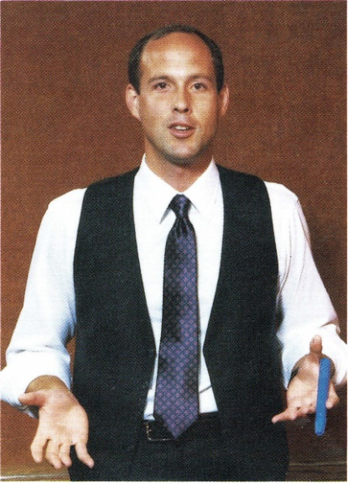
We've asked nearly ten thousand local advertisers, "What do you want from the advertising salespeople who call on you?" Here are ten of their most frequent answers. If one of your goals this year is to give your clients better service, listen to what the retailers and advertisers are asking for and then respond accordingly.
Hard to believe I looked like this when I wrote this article. You can decide whether or not it’s “timeless.” As I read through it, the only thing I might ad is “Help me survive Amazon.”
"Take an interest in my business" is one of the top advertiser wants. Taking an interest is more than filling out a questionnaire. It is really listening to the advertiser. It is caring about the advertiser's business and success as much as your own. Anthony Allesandra writes in Non-Manipulative Selling that people buy because they are understood by the seller, not because they understand everything about the seller's product or service. Good advice is to take a genuine interest in the customer's business.
"Ask me my goals before you try to help me with my advertising." One frustrated Milwaukee advertiser reported that a salesperson told him what his (the advertiser's) goals should be. The salesperson wasn't even close and lost the sale.
"Tailor the proposal to my needs." Advertisers want customized presentations. Station salespeople who bring in the "pack-age-of-the-week" are perceived as not caring much about the client. Clients view top performers as advocates of the clients' needs rather than the station's needs. Handwritten notes and customized presentations work better than off-the-shelf solutions.
"Make an appointment. Don't just drop in on me." Increasingly, professional salespeople are using their time more productively and that includes setting up appointments by phone. One life insurance sales leader calls an appointment the "number one buying signal a client can give you."
Resistance to using the phone comes because of fear of rejection. Top pros take the attitude that it's better to get rejected nine times on the phone and get one firm appointment than to get rejected eight times in person and get two or three firm appointments. Reason: It takes all day to do it in person. And advertisers who do make appointments are in the frame of mind to think about their advertising when you come in.
"Follow up with me after the schedule has run." Salespeople who procrastinate after the schedule should examine their attitudes. Once an order is on the air, your client becomes everyone else's best prospect. You are advertising to the other media salespeople. Marketing experts advise building a wall of service between your customer and the others trying to take your customer away. Service begins before the schedule has ended.
"Be honest with me." In an age of specialized formats and pin-pointed demographics, a station is not all things to all people. Salespeople build credibility by telling what the station cannot do and then focusing on the merchandise and services that it can sell to its listeners. Advertisers complain that everyone claims to be number one, so they tend not to believe anyone who says he or she is. Sales trainers suggest talking about your strengths and how they help the advertiser.
"Don't make me do all the work." Salespeople who work to earn the business are perceived as more professional. Earning the business might mean reading the client's trade magazines, developing copy and demo tapes, conducting consultant-type interviews, clipping articles and information about the client's business, and other tangible displays of concern.
"Let me hear the ad before it runs." Some managers insist that their people read the copy before it is recorded, and play the finished production to the client after it is recorded and before it goes on the air. The time you invest to do it right in the first place will be saved many times over in recuts and in dealing with angry customers.
"Don't whine when you don't get the order." Research shows that top salespeople do not take objections and rejections personally. Instead, they process them as information that will help them sell even more.
"I want a lasting relationship with an advertising person." Sales turnover hurts station credibility. Salespeople who last, often get their unfair share of the call-in business. Salespeople who jump from station to station trying to find the perfect account list need to look at their own behavior. Often the account list reflects the person who is calling on it. Giving the clients the kind of service they want can make this a record year.
(This article originally appeared in Radio Only February 1985. Permission granted to reprint and share with attribution to the author.)

