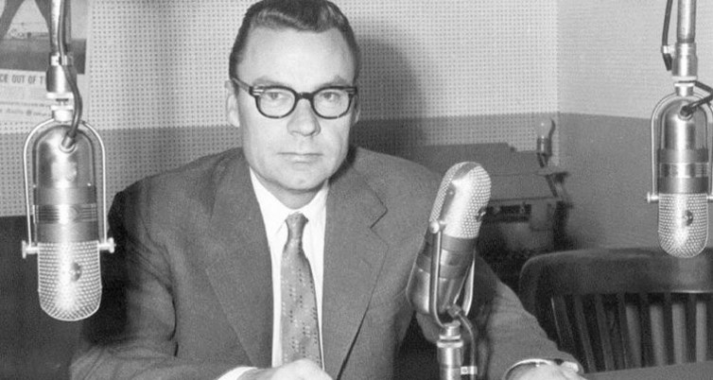It Worked for Me (The Strangest Secret)
When I was I boy, I listened to “Our Changing World” most every morning on WCLT-AM in Newark, Ohio.
Earl Nightingale’s 5-minute program ran every weekday morning at 7:25 AM. It was sponsored by the Park National Bank forever.
When I went to work at WCLT in 1972, I found out that the show was delivered on a 33-1/3 RPM record. When I went to Wikipedia, I discovered that “Our Changing World” was the world’s most syndicated Radio program of its era. More than 7,000 radio stations worldwide carried it.
It was 1973, when I moved to Madison, WI to work for WISM AM and FM.
Soon after I arrived, our sales manager called a meeting and played Earl Nightingale’s gold record The Strangest Secret to the eight salespeople on the team.
“Success is the progressive realization of a worthy goal,” he said.
“You become what you think about,” is another gem.
Over the years, I bought many Earl Nightingale cassette albums. I was listening to one of those albums when Earl Nightingale said this:
One hour per day of study in your chosen field is all it takes. One hour per day of study will put you at the top of your field within three years. Within five years you’ll be a national authority. In seven years, you can be one of the best people in the world at what you do.
I used to study a lot longer than that in college, so I figured I could manage an hour a day.
I read. I attended seminars. I bought more and more cassette tapes from Nightingale-Conant.
I was always learning something new.
Since I was selling advertising, I read a lot about advertising theory. In fact, I read two or three advertising books for every book I read on selling. I figured, if I could get results for my advertisers, they would renew. If the ads didn’t work, it would be a hard sell to get them back on the air.
It worked for me.
Ten years after hearing The Strangest Secret I had started my own business training radio advertising salespeople. Since then, I have conducted 2300+ seminars on three continents. Hundreds of thousands of people have paid a lot of money for me to tell them something they didn’t know.
I was sort or a national authority after seven years of study. Not bad.
Did you know that it takes time and study to be really good at what you do? Are you willing to put in the work?
If you are, I’ll bet you could find a copy of The Strangest Secret and other Earl Nightingale programs on YouTube. I know you could.
Who knows, you may be at the top of your field in three years.
Wouldn’t that be something?
(Permission granted to reprint this article with attribution to the author.)

