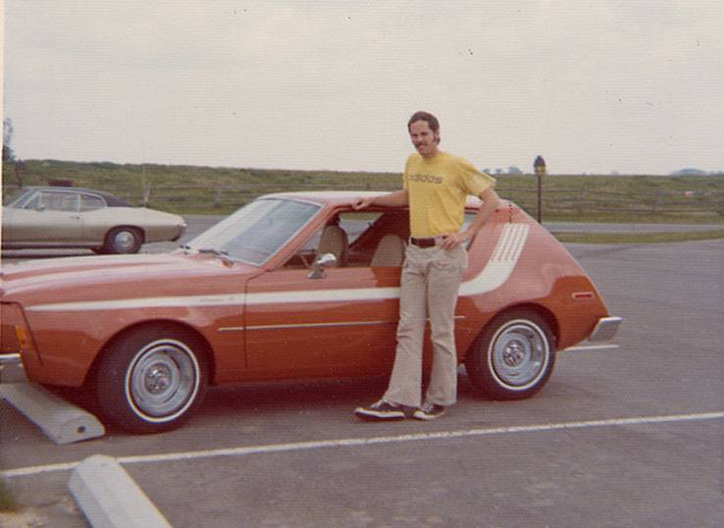
“I Want to Test Your Station”
In the mid-seventies, I had hair, hope and a positive mental attitude. I sold Radio advertising for WISM-AM and FM. I wore a leisure suit, carried a Fiberglas briefcase and drove this orange Gremlin.

I know you probably don’t hear advertisers say, “I want to test your station” anymore. This is an enlightened age. If you do still hear it keep reading.

When I was selling Radio in Madison, Wisconsin I heard it quite a bit. The first time, I walked into my sales manager’s office and asked him how to deal with the advertiser who wanted to “test” our station.

“Chris, the last person to test Radio was Marconi. It’s been perfected. This wouldn’t be an $11 billion industry if it didn’t work. (Radio is now $23 billion industry.) That is word-for-word what Phil Fisher told me. I never forgot it. I’ve used it often.

However, it may come off as smug or smart-alecky depending on the tone of voice in which you say it. So, you need something else to say afterwards.

“I understand. And at the same time . . .” is the panic button answer to every objection or concern you’ll ever deal with. Memorize it:

“I understand. And at the same time, you’re not really testing our Radio station. You’re testing the offer you’re making to our target audience.” Radio advertising doesn’t ‘work.’ Neither does TV or Newspaper advertising. What “works” is the offer you make to the audience.

I was meeting with Jeff Jurkens, the manager of Octopus Car Wash when this conversation occurred:

Jeff: Chris, I’m spending a lot of money with you and I don’t know if it’s working or not. I want to do a test.

Me: Great. What kind of test are you thinking about?

Jeff: If they mention your call letters to the cashier, they get another 10% off the price of their car wash. (The price of a car wash in the early ‘70s was $3.99 with a valid coupon.)

Me: Okay, so that’s a savings of 39 cents off the price of their car wash. And all I have to do is approach the cashier and say WISM (pronounced WIZZ-EM)”

Jeff: Right.

Me: I don’t know if I can get enough listeners to approach your cashiers and say WIZZ-EM for 39 cents, Jeff. But if you were to enter them into a drawing for a Rolex, I know I could get a lot of people to approach your cashiers and say “WIZZ-EM.”

Jeff: I can’t afford to give away a Rolex.

Me: All right. And yet you’re asking me to test a radio station with a market value of $3.1 million for 39 cents. To me, that doesn’t seem like a fair test.

Jeff: Hmmm. Well when you put it that way . . .”

Me: Somewhere between 39 cents and a Rolex there is probably is a fair test. Let’s talk about the results you’re looking for from the next ads we run.

Acknowledge the advertiser’s need to test and then develop a test that is fair. Good questions to ask as you’re designing the test are these:
- What are your goals for this ad or campaign?
- How will you observe or measure the success or failure of this test?
- How has the product you’re advertising at this price done in other media?
- What happens is this ad fails?
- How have you tested the results in other media?

(Permission granted to reprint this article with attribution to the author Chris Lytle.)

