I Guaranteed My Seminar and Here’s What Happened
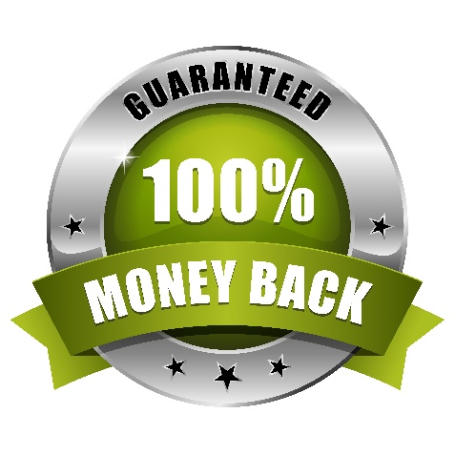
Radio Sales $101 was my full day seminar for brand new Radio advertising sales reps.
It cost $101.
We had a 180-day money back guarantee.
The day after attending the seminar with his salespeople, a manager called Sarah (my business partner and wife). "One of my salespeople quit her job in the car on the way home from Chris's seminar," he said.
"I'll be happy to send you a refund, " Sarah volunteered.
"No thanks. It was worth $101 to find out that she didn't want to work that hard. I might have held onto her and paid her for six more months before I found that out.
Sales training can develop the people who develop your top line revenues. It can also expose people who don't have the drive or the inclination to sell for you.
Either way you win.
(Permission granted to reprint with attribution to the author.)

