How to Get Your Sales Meetings (and Salespeople) Out of Their Ruts
Change meeting locations. Conduct brag sessions. Fixing the most common mistake.
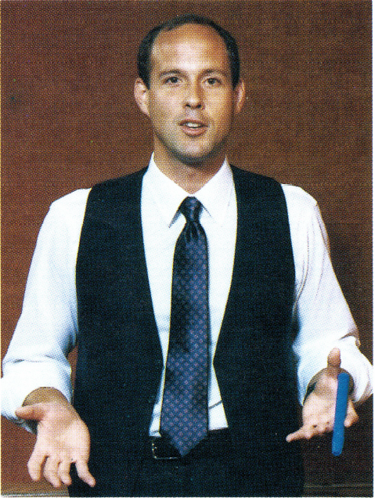
Sales managers looking for ways to break salespeople out of ruts may want to look at breaking out of their own sales meeting ruts.
Running a sales meeting at the same time and with the same agenda every week is like being an advertiser who never changes copy. Salespeople often complain that sales meetings are nothing more than "live memos."
Here are some ideas sales managers are using to put their sales meetings on a higher plateau.
Let the customer come to the meeting. Inviting a retailer or agency person to your meeting to talk about his/her business is a way to focus the salespeople on client's needs instead of the station's needs. Ask guest clients to discuss issues and trends in their industries. Give the client a gold Cross pen engraved with your call letters. After the client has left, discuss ways to use what you've learned to help that client.
I wrote this article in 33 years ago. About the only thing I would change is the advice to rent a film. Obviously, you can get video online for free and probably already are. CL
Change the meeting location. Hold the sales meeting at a downtown hotel, a community meeting room or a shopping center. Charge "admission" to the sales meeting. Admission in this case could be two scheduled appointments with nearby retailers or agencies. This "change of place" strategy ends the costly hanging-around-the-radio-station-after-the-sales-meeting syndrome.
Conduct brag sessions. Single out a salesperson who has sold a particularly difficult client or an unusually large schedule. Let that salesperson take the rest of the people through the process. This meeting motivates the teller and puts some peer pressure on the rest of the group. Finally, discuss which tough accounts everyone is working on.
Change the time of the meeting. Some stations now hold sales training meetings on Wednesdays. The feeling is that people need a boost on "hump day" to get them to work harder on Thursday and Friday. Some stations have moved their Monday morning meeting to Tuesday. Reason: Everyone else has a Monday morning meeting so let's be the first sales team in the week that many advertisers see.
Rent a film. Many state universities have collections of instructional films on selling, advertising and business in general. These films are available at a low cost to businesses. Use the film as the basis for a discussion after the meeting.
Learn a business in one hour. Another meeting with an "admission charge." Require salespeople to pick up a trade magazine from a client or prospect and bring it to the meeting. Then give everybody 15 minutes in the meeting to read the magazine. Have them take notes on the jargon words and write down three questions they'll ask the client on the next call. Then, give everybody five minutes to describe the industry they just researched. This trade magazine information "blitz" gets salespeople thinking about the problems and current issues of the businesses. They also get more excited about the businesses because they understand them better.
Bring in an outside speaker. In your market there are all kinds of interesting people who would be willing to come to your sales meetings and who can contribute to your selling efforts. College professors, local seminar leaders, the football coach and politicians all have a 45-minute talk they can give at a moment's notice. Here are some specific topics and guest speakers that sales managers like.
- The Chamber of Commerce director can discuss the market and the business opportunities that exist right now.
- A salesperson from another industry can teach selling skills and give intelligence reports on certain industries.
- Ask a sales manager from another market to run your meeting. The guest sales manager will bring in some outside thinking and can be another resource for your staff. You can return the favor the following month.
Managers who want to break salespeople out of ruts can ask these questions:
- How will this meeting I am planning help the people who attend it succeed faster?
- Would I want our best advertiser to attend this meeting? This is an important question because as soon as the meeting is over, your salespeople will be using the information from the meeting with your best customers and prospects.
- If the salespeople didn't have to come to this meeting to keep their jobs, would they want to come anyway?
Experts advise having an agenda. This lets salespeople know in advance what is going to happen and what to expect. Agendas also prepare the presenter. If you've planned the meeting, it is a better meeting.
Successful sales managers manage the meeting and not the people in it. Use the meeting to focus on behavior that will improve everyone without singling out anyone. If people feel they have to defend themselves in a sales meeting they spend too much time thinking about what they will do to protect themselves.
Adult educators say that adults learn through a variety of the senses. Visual aids, audio, films, discussions, quizzes, learning games and exercises are often better than a straight lecture.
A good sales meeting is like a good sales call. Both should be an open exchange of information instead of a one-sided pitch. Listening to your salespeople is as important as your talking. Demonstrate a willingness to listen. New learning theory states that people learn best when they can relate the new techniques to things they already know.
(This article originally appeared in Radio Only (January 1985.) Permission granted to reprint and share with attribution to the author.)

