**Your State Broadcasters Association presents . . .**

**“Work smarter not harder.”**

Great advice. It’s easy to tell salespeople, “Work smarter, not harder.” It’s just that nobody tells what that means and how to do it.

Until now.

If your quota for 2018 is **more** than it was this past year, then plan to attend this Webinar before you hit the streets in January.

Let’s face it:

* Wall Street wants more.
* The Board wants more.
* Ownership wants more.

That means sales managers start demanding more: more activity, more proposals, more sales.

Owners and sales managers seem to have only two buttons they push:

1. The More Button and
2. The Panic Button.

This fast-paced, highly-detailed Webinar provides sales managers and salespeople with the HOW Button!

[**Free Registration**](https://register.gotowebinar.com/rt/3109927244477286914)

Click either date and we’ll send you a confirmation and link to the Webinar.

[Wednesday, December 20, 2017 at 12 PM CST](https://register.gotowebinar.com/rt/3109927244477286914)

[Tuesday, January 9, 2018 at 12 PM CST](https://register.gotowebinar.com/rt/3109927244477286914)

One registration per station or cluster, please. Watch this in your conference room with your sales team.

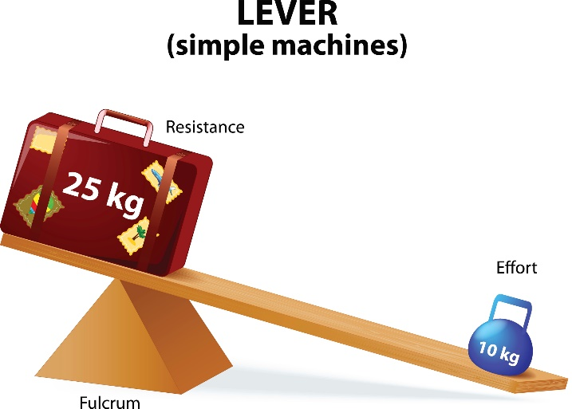

**Leverage: Double Your**

**Billing with Half the Effort**

Plan to attend this fast-paced, highly-detailed LIVE Webinar. It’s personally conducted by Chris Lytle, who promises *more usable information per minute* than any session you’ll ever attend. Gain proven strategies for doubling your billing.

From the webinar outline:

* Applying the first rule of selling starting now
* **The *only* three strategies for growing sales**
* Tool bonus: Lytle’s account list management system
* **Measuring the quality of the meeting and not just the number of calls**
* Understanding the seven components of your billing
* **Knowing the critical difference between personal dollars and business dollars**
* What does “big order” mean to you?
* **How to ask for bigger orders and get them**
* The “instant” 15% sales increase ask
* **How an hour of planning can save you a month of misery**
* How to “talk advertising” instead of rates and ratings
* **Why you should have a minimum order**
* The easy way and the hard way to double your billing

--and much more

Chris Lytle is the best-selling author of *The Accidental Salesperson* and *The Accidental Sales Manager.* His new book is *23 Shockingly Simple Sales Ideas.* This Webinar is will deliver powerful tools and ideas to help you grow your business.

**A person posing for the camera

Description generated with very high confidenceA picture containing primate, animal, ape

Description generated with high confidence**

“Give me a lever long

enough and a fulcrum

on which to place it, and I shall move the world.”

--Archimedes

Give me 75 minutes online and I’ll show you how to double your billing in 2018 with half the effort.

--Lytle